**6.6 Similar Triangle Proofs Exit Ticket**

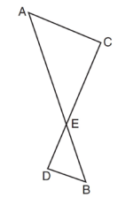Screen%20Shot%202017-01-05%20at%209.59.22%20PM.png

Prove:

Screen%20Shot%202017-01-05%20at%2010.19.20%20PM.png